SQL Analytical Queries

Executive KPIs:
-- Total Staffed Bed Days and Total Occupied Bed Days
SELECT
SUM(AllStaffedBeddays) AS Total_Staffed_Bed_Days,
SUM(TotalOccupiedBeddays) AS Total_Occupied_Bed_Days
FROM analytics.beds_clean;
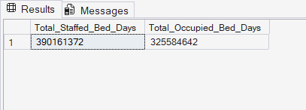
-- Average Occupancy
SELECT
ROUND(AVG(PercentageOccupancy), 2) AS Avg_Occupancy_percentage
FROM analytics.beds_clean;
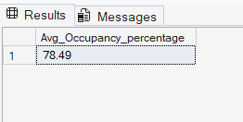
-- Number of NHS Boards
SELECT
COUNT(DISTINCT HB) AS Total_NHS_Boards
FROM analytics.beds_clean;
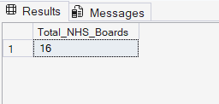

-- Number of Specialties
SELECT
COUNT(DISTINCT SpecialtyName) AS Total_Specialties
FROM analytics.beds_clean
WHERE Specialty_Level = 'Detailed';
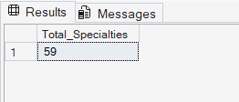

--Which NHS Boards experience the Highest occupancy and Lowest occupancy?
WITH agg_join AS(
SELECT
d.NHS_Board_Name,
SUM(CAST(f.TotalOccupiedBeddays AS BIGINT))* 100/SUM(CAST(f.AllStaffedBeddays AS BIGINT))
AS Occupancy_Percentage
FROM analytics.beds_clean f
JOIN analytics.dim_nhs_board d
ON f.HB = d.HB_Code
WHERE f.Location_Level = 'NHS Board Aggregated'
AND d.HB_Code <> 'S92000003'
GROUP BY d.NHS_Board_Name
),
Ranking AS(
SELECT
NHS_Board_Name,
Occupancy_Percentage,
RANK() OVER(ORDER BY Occupancy_Percentage DESC) AS Highest_Rank,
RANK() OVER(ORDER BY Occupancy_Percentage ASC) AS Lowest_Rank
FROM agg_join
)
SELECT
NHS_Board_Name, Occupancy_Percentage,
CASE
WHEN Highest_Rank = 1 THEN 'Highest Occupancy'
WHEN Lowest_Rank = 1 THEN 'Lowest Occupancy'
END AS Occupancy_Status
FROM Ranking
WHERE Highest_Rank = 1 OR Lowest_Rank = 1;
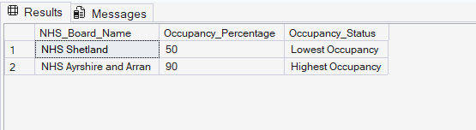

-- Which NHS Boards has the highest and lowest average bed availability
WITH available_beds AS(
SELECT d.NHS_Board_Name,
ROUND(AVG(f.AverageAvailableStaffedBeds), 2) AS Avg_Available_Beds
FROM analytics.beds_clean f
JOIN analytics.dim_nhs_board d
ON f.HB = d.HB_Code
WHERE Location_Level = 'NHS Board Aggregated'
AND HB_Code != 'S92000003'
GROUP BY d.NHS_Board_Name
),
ranking AS(
SELECT
NHS_Board_Name, Avg_Available_Beds,
RANK() OVER(ORDER BY Avg_Available_Beds DESC) AS Highest_Rank,
RANK() OVER(ORDER BY Avg_Available_Beds ASC) AS Lowest_Rank
FROM available_beds
)
SELECT
NHS_Board_Name, Avg_Available_Beds,
CASE
WHEN Highest_Rank = 1 THEN 'Highest Availability'
WHEN Lowest_Rank = 1 THEN 'Lowest Availability'
END AS Availability_Status
FROM ranking
WHERE Highest_Rank = 1 OR Lowest_Rank = 1;
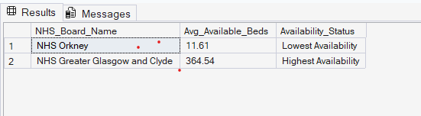

-- Which NHS Boards currently have the greatest staffed bed capacity?
SELECT
d.NHS_Board_Name,
ROUND(f.AverageAvailableStaffedBeds, 2) AS Current_Available_Beds
FROM analytics.beds_clean f
JOIN analytics.dim_nhs_board d
ON f.HB = d.HB_Code
WHERE f.Location_Level = 'NHS Board Aggregated'AND d.HB_Code != 'S92000003' AND
f.SpecialtyName = 'All Specialties' AND -- Each board has multiple specialty-level records so use aggregrated 'All Specialties'
f.Quarter = (
SELECT MAX(Quarter)
FROM analytics.beds_clean
WHERE Location_Level = 'NHS Board Aggregated')
ORDER BY Current_Available_Beds DESC;
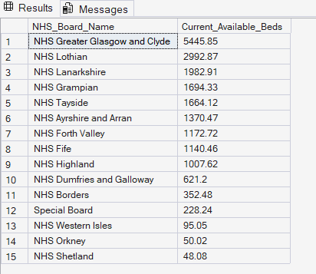

-- Which specialties experience the greatest capacity pressure.
WITH specialty_occupancy AS(
SELECT
SpecialtyName,
ROUND(
SUM(TotalOccupiedBeddays) * 100.0/
NULLIF(SUM(ALLStaffedBeddays), 0), 2) AS Occupancy_Percentage
FROM analytics.beds_clean
WHERE Specialty_Level = 'Detailed'
GROUP BY SpecialtyName
)
SELECT
SpecialtyName,
Occupancy_Percentage,
DENSE_RANK() OVER(ORDER BY Occupancy_Percentage DESC) AS Occupancy_Rank
FROM specialty_occupancy
ORDER BY Occupancy_Rank;
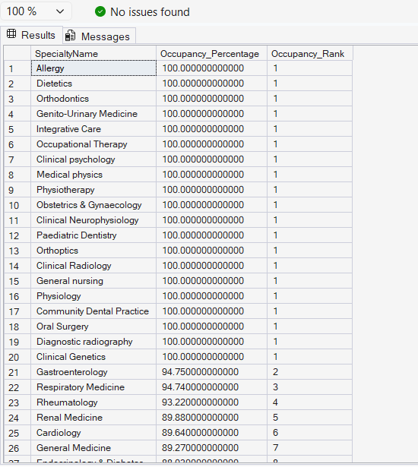

-- How have bed availability and occupancy changed over time by quarter?
SELECT
Quarter,
Quarter_Start_Date,
ROUND(AVG(AverageAvailableStaffedBeds), 2) AS Avg_Available_Beds,
ROUND(SUM(TotalOccupiedBeddays) * 100.0/
NULLIF(SUM(ALLStaffedBeddays), 0), 2) AS Occupancy_Percentage
FROM analytics.beds_clean
WHERE Location_Level = 'NHS Board Aggregated' AND
SpecialtyName = 'All Specialties'
GROUP BY Quarter, Quarter_Start_Date
ORDER BY Quarter_Start_Date;
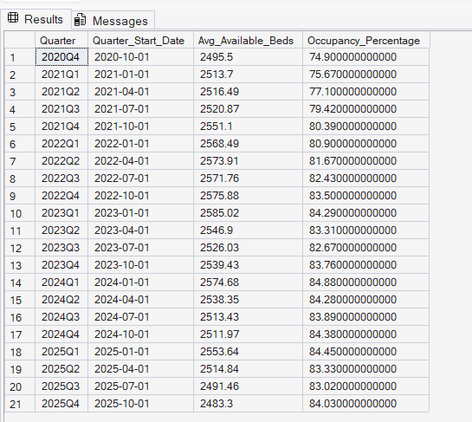

-- How have bed availability and occupancy changed year over year?
WITH yearly_agg AS(
SELECT
Year,
ROUND(AVG(AverageAvailableStaffedBeds), 2) AS Avg_Available_Beds,
ROUND(SUM(TotalOccupiedBeddays) * 100.0/
NULLIF(SUM(ALLStaffedBeddays), 0), 2) AS Occupancy_Percentage
FROM analytics.beds_clean
WHERE Location_Level = 'NHS Board Aggregated' AND
SpecialtyName = 'All Specialties'
GROUP BY Year
),
absolute_change AS(
SELECT
Year,
Avg_Available_Beds, Occupancy_Percentage,
LAG(Avg_Available_Beds) OVER(ORDER BY Year) AS Previous_Year_Beds,
LAG(Occupancy_Percentage) OVER(ORDER BY Year) AS Previous_Year_Occupancy,
(Avg_Available_Beds-LAG(Avg_Available_Beds) OVER(ORDER BY Year)) AS Bed_Change,
(Occupancy_Percentage - LAG(Occupancy_Percentage) OVER(ORDER BY Year)) AS Occupancy_Change
FROM yearly_agg
),
percent_change AS(
SELECT
Year,
Avg_Available_Beds,
Bed_Change,
ROUND(Bed_Change * 100.0/ NULLIF(Previous_Year_Beds, 0), 2) AS Bed_Change_Percent,
Occupancy_Percentage,
Occupancy_Change,
ROUND(Occupancy_Change * 100.0/ NULLIF(Previous_Year_Occupancy, 0), 2) AS Occupancy_Change_Percent
FROM absolute_change
)
SELECT * FROM percent_change
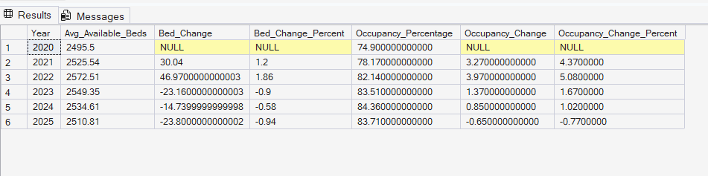

-- Which regions (NHS Board) and specialties should be prioritized for resource allocation?
WITH resource_allocation AS(
SELECT
d1.NHS_Board_Name,
d2.Specialty_Name,
ROUND(SUM(f.TotalOccupiedBeddays) * 100.0/
NULLIF(SUM(f.AllStaffedBeddays), 0), 2) AS Occupancy_Percentage,
ROUND(AVG(AverageAvailableStaffedBeds), 2) AS Avg_Available_Beds
FROM analytics.beds_clean f
JOIN analytics.dim_nhs_board d1
ON f.HB = d1.HB_Code
JOIN analytics.dim_specialty d2
ON f.Specialty = d2.Specialty_Code
WHERE f.Location_Level = 'NHS Board Aggregated'
AND f.Specialty_Level = 'Detailed'
AND d1.HB_Code != 'S92000003'
GROUP BY d1.NHS_Board_Name, d2.Specialty_Name
)
SELECT
NHS_Board_Name,
Specialty_Name,
Avg_Available_Beds,
Occupancy_Percentage,
RANK() OVER(ORDER BY Occupancy_Percentage DESC, Avg_Available_Beds ASC) AS Resource_Priority_Rank
FROM resource_allocation
ORDER BY Resource_Priority_Rank;
